PathSimR – Urology Mixed Pathway Example

# Problem

## Project title & summary

**Understanding bottlenecks in a hypothetical Urology Pathway**

The pathway modelled in this project represents a mix of outpatient clinics and an inpatient bedded ward, framed in a urology setting. This basic framework was created after discussions with urology service commissioners and showcases key features of real pathways.

Each of the clinics and the inpatient elective ward have queues (a single queue each) before them. In this example, these queues are not physical waiting spaces but instead represent all people waiting for the next available clinic space. There is therefore no upper limit to the queue length as people can wait in their homes until the next space is available. This pathway network’s primary goal is to provide insight into bottlenecks in the system, to see where demand outstrips capacity.

## Key PathSimR Features

* Infinitely large internal queue system
* Calendar driven capacity (including clinics that close)
* Mixed pathway
  + Outpatient clinics
  + Inpatient bedded ward
* Mix of Service Distributions

## Key questions & insights

* Which services have growing queues?
* Is it a better strategy to increase the length of time that the clinics are open or increase the number of staff at each service point?

## Summary of services along patient pathway

|  |  |  |
| --- | --- | --- |
| Service Point | Service Point Type | Description |
| GP Referral (GP_Ref) | Fixed Hours service | * Service operates between 9am & 6pm everyday * 10 GPs available * Appointments take between 12 & 24 minutes (modelled as uniform distribution with min = 0.2 & max = 0.4) |
| Hospital Clinic (H_C) | Fixed Hours service | * Service operates between 9am & 3pm everyday * 6 staff available * Appointments take between 15 & 45 minutes (modelled as uniform distribution with min = 0.25 & max = 0.75) |
| Hospital Diagnostics (H_D) | Fixed Hours service | * Service operates between 12pm & 6pm everyday * 7 staff available * Appointments take between 15 & 45 minutes (modelled as uniform distribution with min = 0.25 & max = 0.75) |
| Hospital Ward (H_W) | Continuous Bedded Unit | * 75 beds available * Treatment takes on average 4 days(modelled as exponential distribution with rate = 0.0104) |
| Bladder & Bowel Clinic (B_B) | Fixed Hours service | * Service operates between 10am & 12pm everyday * 8 staff available * Appointments take between 15 & 30 minutes (modelled as uniform distribution with min = 0.25 & max = 0.5) |
| Blended Clinical Triage (BCT) | Fixed Hours service | * Service operates between 9am & 3pm everyday * 9 staff available * Appointments take between 15 & 30 minutes (modelled as uniform distribution with min = 0.25 & max = 0.5) |
| Community Clinic (CC) | Fixed Hours service | * Service operates between 9am & 12pm everyday * 10 staff available * Appointments take between 15 & 45 minutes (modelled as uniform distribution with min = 0.25 & max = 0.75) |
| Community Follow-Up (CF) | Fixed Hours service | * Service operates between 12pm & 3pm everyday * 5 staff available * Appointments take between 15 & 45 minutes (modelled as uniform distribution with min = 0.25 & max = 0.75) |
| Specialist Clinic (SC) | Fixed Hours service | * Service operates between 9am & 12pm everyday * 10 staff available * Appointments take between 15 & 45 minutes (modelled as uniform distribution with min = 0.25 & max = 0.75) |
| Specialist Follow-Up (SF) | Fixed Hours service | * Service operates between 12pm & 3pm everyday * 5 staff available * Appointments take between 15 & 45 minutes (modelled as uniform distribution with min = 0.25 & max = 0.75) |

## Summary of exits from patient pathway

|  |  |  |
| --- | --- | --- |
| Exit | Possible Discharge Delay | Description |
| Home | No Delay |  |

## External arrival rates to the patient pathway and queue capacity

|  |  |  |
| --- | --- | --- |
| Service Point | Arrival Rate Estimation | Queue Capacity |
| GP Referral (GP_Ref) | 6 per hour | **External:** 9999  **Internal:** 0 |
| Hospital Clinic (H_C) | 0 per hour | **External:** 0  **Internal:** 9999 |
| Hospital Diagnostics (H_D) | 0 per hour | **External:** 0  **Internal:** 9999 |
| Hospital Ward (H_W) | 0 per hour | **External:** 0  **Internal:** 9999 |
| Bladder & Bowel Clinic (B_B) | 0 per hour | **External:** 0  **Internal:** 9999 |
| Blended Clinical Triage (BCT) | 0 per hour | **External:** 0  **Internal:** 9999 |
| Community Clinic (CC) | 0 per hour | **External:** 0  **Internal:** 9999 |
| Community Follow-Up (CF) | 0 per hour | **External:** 0  **Internal:** 9999 |
| Specialist Clinic (SC) | 0 per hour | **External:** 0  **Internal:** 9999 |
| Specialist Follow-Up (SF) | 0 per hour | **External:** 0  **Internal:** 9999 |

## Features of the patient pathway

|  |  |  |
| --- | --- | --- |
| Service Point | Onward Service Points or Exits | Additional Information |
| GP Referral (GP_Ref) | Hospital Clinic (H_C): 50%  Bladder & Bowel Clinic (B_B): 15%  Blended Clinical Triage (BCT): 35% |  |
| Hospital Clinic (H_C) | Hospital Diagnostics (H_D): 90%  Home: 10% |  |
| Hospital Diagnostics (H_D) | Hospital Ward (H_W): 20%  Home: 80% |  |
| Hospital Ward (H_W) | Community Follow-Up (CF): 50%  Specialist Follow-Up (SF): 50% |  |
| Bladder & Bowel Clinic (B_B) | Blended Clinical Triage (BCT): 100% |  |
| Blended Clinical Triage (BCT) | Community Clinic (CC): 40%  Specialist Clinic (SC): 40%  Home: 20% |  |
| Community Clinic (CC) | Hospital Diagnostics (H_D): 10%  Community Follow-Up (CF): 10%  Home: 80% |  |
| Community Follow-Up (CF) | Home: 100% |  |
| Specialist Clinic (SC) | Specialist Follow-Up (SF): 10%  Home: 90% |  |
| Specialist Follow-Up (SF) | Home: 100% |  |

## Assumptions and limitations

In order to simplify the pathway, Uniform distributions were used to model the service times in the clinics. This means that there is an equal probability that the appointment will take any amount of time between the minimum and maximum values. This approach was taken instead of setting an explicit length (i.e. every appointment takes exactly 20 minutes) for each appointment in order to include some variability in the system.

# Inputs

## Pathway Figure

Entering the pathway information above into the PathSimR Pathway Wizard, a set of model inputs and a pathway visualisation were automatically created. The pathway diagram (a static version of the tool output is presented in figure 1) serves as a sense check on whether the inputs have been entered correctly, and can inform discussion about what parameters or service point configurations might be varied in what-if analysis.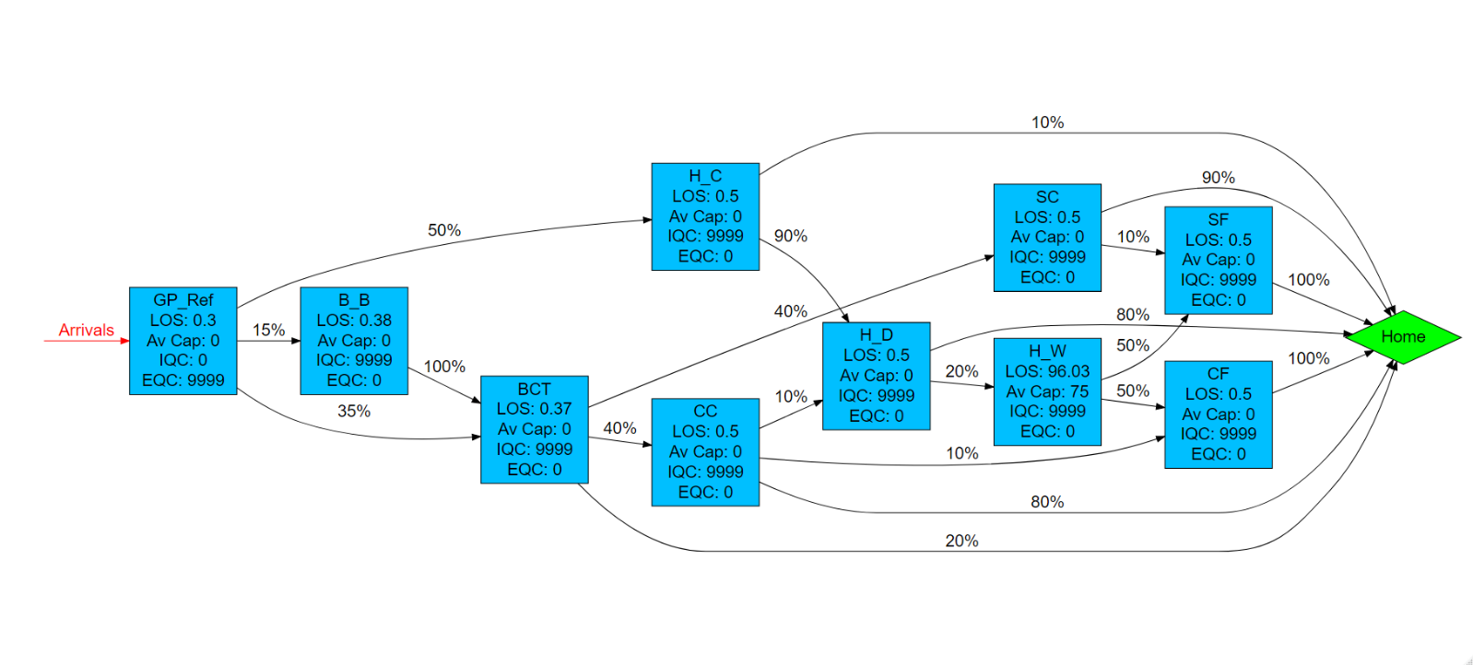

Figure 1

## Input templates

The Pathway Wizard also creates the following two parameter dataframes, which are used to generate the simulation. If the user has entered the data directly into the Pathway Wizard, it can be passed straight to the simulation model without the need for the user to interact directly with these files – but they can be downloaded and saved, then subsequently re-uploaded to PathSimR if the user wishes to run the simulation again without having to re-enter data into the wizard, or if they wish to make changes to specific parameters (e.g. for sensitivity analysis, or “what-if” comparison on the effect of different capacities in given service points).

***Network template***

This template, and extract of which is shown in figure 2, includes transition rates between individual service points and exits, as well as service time parameters and permitted queue lengths for each service point. Note the service points each appear multiple times in the column headers, and the table is truncated at the right.



Figure 2

***Calendar template***

This template, shown in figure 3, includes the arrival schedule (times and associated arrival rates – possibly zero) and the capacity for each service point with a defined capacity and service time. (Note that the table is truncated at the bottom).



Figure 3

# Outputs summary

Caution is necessary when interpreting the occupancy measures for service points which are closed for substantial portions of the simulation time (e.g. clinics closed overnight), since average measures of occupancy will deflate the occupancy levels when they are in active use.

From the plot of percent of simulation time at given occupancy level given in figure 4 below, it is evident that there are capacity constraints at “GP_Ref”, “H_C”, “H_D” and “BCT”, as evidenced by the spikes in occupancy frequency at the extreme end of their capacity (the bars on the right hand side), as well as on the left at zero occupancy (when they are closed).

**Graphical summary of occupancy**

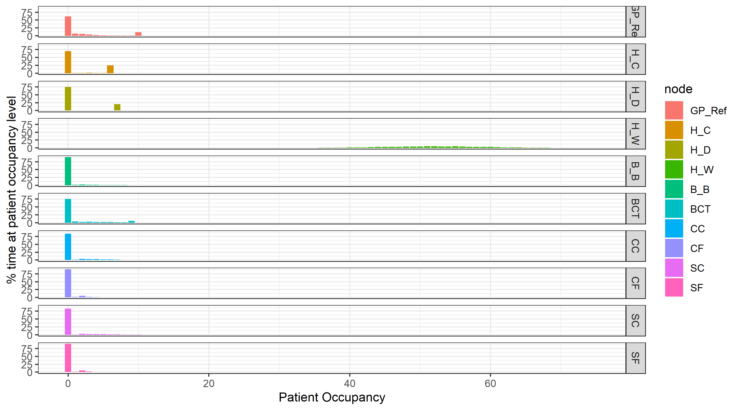

Figure 4

The main output measure of interest in this use case is queue size. Figure 5 below shows that substantial queues should be expected at “GP_Ref” (mean 35.44 patients waiting, and 5% of the time more than 85 patients waiting) and “HC” (mean 24.52 patients waiting, and 5% of the time more than 69 patients waiting), with smaller queues for other service points.

**Graphical summary of queue sizes**

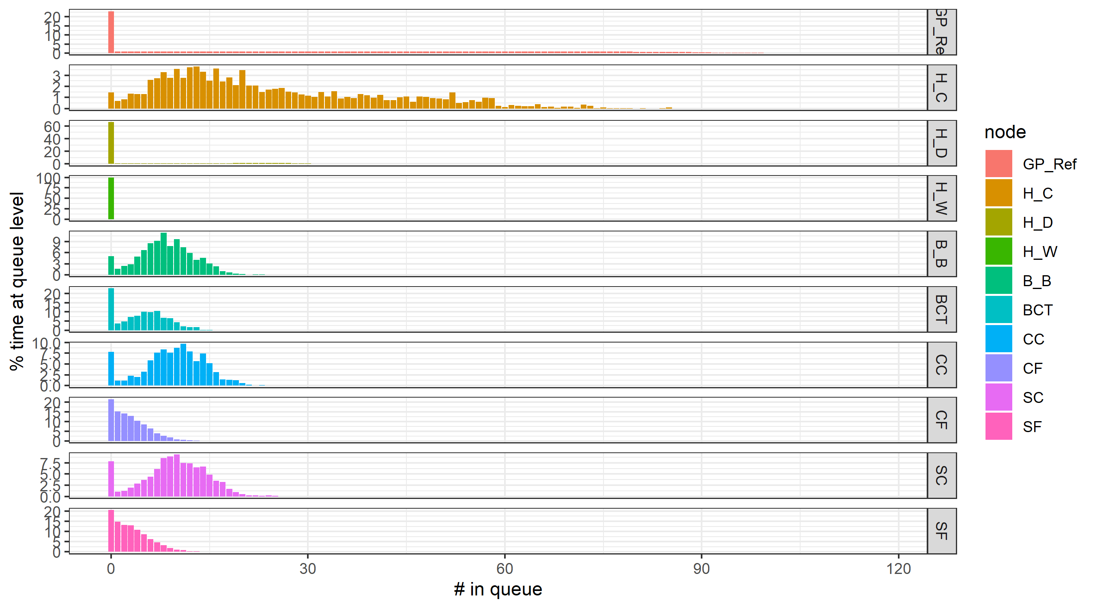

Figure 5

Further details of queue size are shown in figure 6 below

**Numerical summary of queue sizes**

|  |  |  |  |  |  |  |  |
| --- | --- | --- | --- | --- | --- | --- | --- |
|  | **Queue percentiles** | | | | | | **Mean queue** |
| **node** | **80th** | **85th** | **90th** | **95th** | **99th** | **100th** |  |
| **GP_Ref** | 66.95 | 72.71 | 78.63 | 85.83 | 96.39 | 118 | 35.45 |
| **H_C** | 39.57 | 44.73 | 50.11 | 56.37 | 69.93 | 88 | 24.52 |
| **H_D** | 16.19 | 20.1 | 23.32 | 26.5 | 30.63 | 39 | 5.99 |
| **H_W** | 0 | 0 | 0 | 0 | 0 | 6 | 0.00 |
| **B_B** | 11.38 | 12.33 | 13.5 | 14.88 | 17.52 | 23 | 8.38 |
| **BCT** | 7.54 | 8.29 | 9.08 | 10.46 | 12.65 | 18 | 4.76 |
| **CC** | 13.11 | 13.78 | 14.64 | 16.02 | 18.99 | 23 | 9.47 |
| **CF** | 4.65 | 5.32 | 6.16 | 7.62 | 10.46 | 18 | 2.95 |
| **SC** | 13.37 | 14.16 | 15.27 | 16.76 | 20.1 | 25 | 9.68 |
| **SF** | 4.86 | 5.6 | 6.53 | 7.85 | 10.68 | 18 | 3.10 |